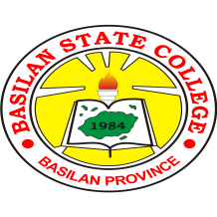
Republic of the Philippines
BASILAN STATE COLLEGE
Office of the BIDS AND AWARDS COMMITTEE
Main Campus Sumagdang, Isabela City, Basilan
Tel. No. 062-200-7523
www. Bassc.edu.ph

INVITATION TO BID
Vision:
A center of excellence in instruction, research, extension and production directed towards global and sustainable human development.

The Basilan State College (BaSC), through its Bids and Awards Committee (BAC), will undertake a Public Bidding for the “Rehabilitation of the Student Center at Basilan State College – Sta. Clara Extension Campus, Lamitan City, Basilan” in accordance with the Implementing Rules and Regulations of Republic Act No. 9184.

Name of Project : Rehabilitation of the Student Center at Basilan State College – Sta.
Clara Extension Campus, Lamitan City, Basilan

Location : Basilan State College, Isabela City, Basilan
Mission:
Basilan State College shall provide quality human resources equipped with adequate knowledge, skills, and attitude in technological, vocational and professional fields of instruction, research, extension, and production to improve the quality of life of its clientele.

Approved Budget of : Three Million Four Hundred Eighty-Two Thousand Five Hundred
the Contract Pesos Only (P 3,482,500.00)

Date of Pre-Bid : December 3, 2018, 10:00 am at the Conference Room, Administrative Conference Building, Basilan State College, Isabela City, Basilan
Date of Opening : December 17, 2018, 10:00 am at the Conference Room, Administrative
of Bids Building, Basilan State College, Isabela City, Basilan

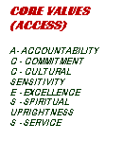
Delivery Date : Seven (7) days upon Signing of Contract Agreement and receipt of Notice to Proceed
Interested suppliers are required to submit their eligibility documents, technical proposal, and financial proposal and price quotation (Annex “A”).
Submission of quotation and eligibility documents is on or before 10:00 a.m. of December 17, 2018, at the Conference Room, Administrative Building, Basilan State College, Isabela City, Basilan
For inquiry, you may contact us at cel. no. 09063748056/09957982366 or email us at basc.cao@gmail.com

Very truly yours,

NENENG M. MONTONG-HUSIN
BAC Chairperson

Basc.cao@gmail.com
(+63) 9157784922
BaSC Main Campus Administration Bldg.,Isabela City, Basilan

